**Casablanca Project Report**

Walid Harkous

Wentworth Institute of Technology

Databases

COMP 2650-01

Nguyen Thai

December 11, 2020

**The Problem**

The responsibility of opening a restaurant is no easy task. It takes a lot of time, money, and sweat to have everything up and running smoothly. The most important part of any restaurant or company is the centralized storage systems. Some companies opt for servers or some Big Companies go for mainframes. My small to medium sized restaurants do not require such powerful devices. I will be using a Database Management System (DBMS) to store all critical operation information ranging from the types of food items I will be selling, to the facilities and renovation costs of restaurants, to where each store is located, who worked there, who ate there, and so much more information. This information will all be crucial in allowing my business to grow bigger and healthier. Analysis is a key component to any successful business and what better way to analyze your customer transaction and employee satisfaction than through the use of Oracle DB, which I have used for this project.

The main problem I am trying to solve is to create a working relational database that will allow me to store, retrieve, and manipulate data about my business operations. I must first go through the steps of creating a working database with relational tables that properly define the constraints. This is important in a functional business since I would not want sensitive information like customer data or access to things like weekly orders to those that do not have permission to access. This is the primary reason for going through the process of creating ERD’s and tables and normalization.

**The Business Statement**

The key components of some of the business operation will be related to what products will I be providing. For the Main Dishes, I will provide courses like Couscous, Tajine (lamb, chicken, Kefta, Salmon), Rafisa, Pastilla. For Entrees, I will provide meals such as Baghrir, Mesemen, Harsha, Kebab, Harira, Lentil soup. Side dishes will include Escargot Soup, Sambuusa, Za’look, Moroccan Salads, Olives with Hummus and Harissa. Optional Pastries will also be provided like Shebakia, Sello, Briwat w/ chicken, Feq’as, Gazelle Horn, Briwat w/ almond, Milfeull (Napolean). Of course, a restaurant must provide beverages so I for drinks I will have Mint Tea, Arabic Coffee, Water, Carrot Orange juice.

This is my original business statement which has helped me tremendously by listing some of the entities that will exist within my database. This was only the start however, as I was only focused on the kitchen portion of my business. A restaurant is all about food after all, and If my menu was not regional-correct or was too varied, it would be a problem for business as most analysis show. I would then shift my focus to some of the more major key components of my business operations.

The key components will be what facilities and equipment I will be using in the business operation. For this project, I will be using a single-story restaurant-style building. Equipment that is necessary for the business operation include: A gas-operated Oven, Stove, Walk-in refrigerating storage, Walk-in freezing storage, Dishes, Utensils, 3-compartmenet sink, Drink cooler, special regional cookware. Another key aspect of the business operation components is how I will be managing employees and finances. I will use a standard clock-in and clock-out payroll system. My employee will be paid hourly depending on their position. Waiters and waitresses will be paid in tips. I think this is the standard practice in most restaurants.

Defining what equipment my restaurants will be using, which employees I will require, what type of payment option will I be using and even if they are salaried or hourly. These all play a major role in the operation of a business and laying out these parts will make my transition to creating ERD’s a lot easier since I will already know which entities I need to add. The only thing left to do is to define the logistics and constraints of these entities, giving them attributes such as ID’s and names.

**The Business Model**

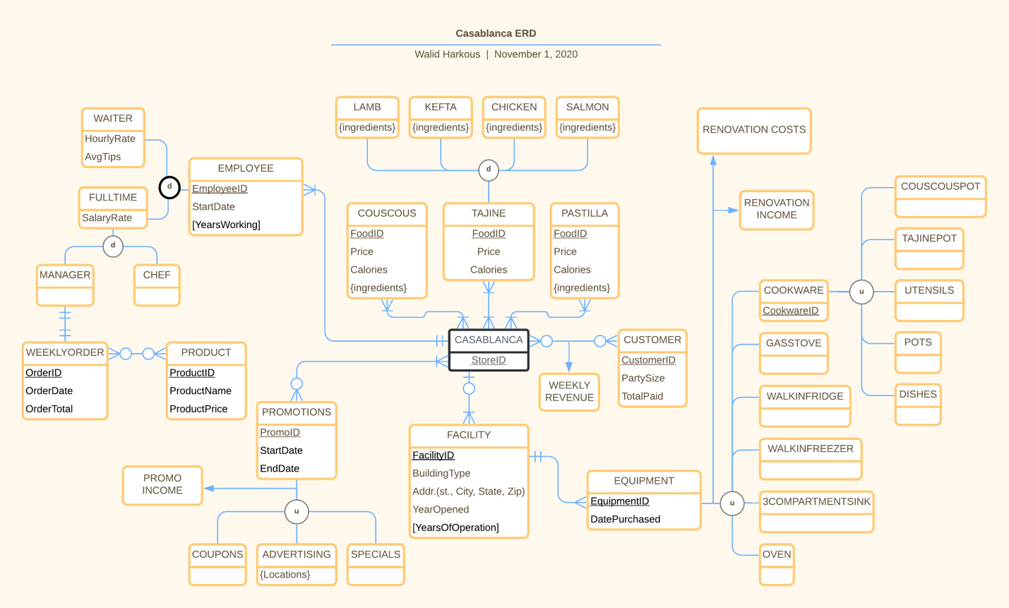

This is the ERD that I came up with to represent my business model. It featured all f the primary key components of my business statement that I mentioned in the previous section. The top part relates the food being sold at restaurants. Restaurants have the option to sell or not sell which food they please. This allows each store to analyze their reports and see which food isn’t doing too well and choose to remove the item from their menu. The three foods I have chose are only a sample of the menu and those three represent the most popular food items on the menu. The right section refers to the equipment I talked about. There are many subtypes that must be broken down later in 3rd Normal Form. In the bottom is the facilities and what equipment they will be holding. Most of the equipment is mandatory but some facilities do not have the space for some equipment such as drive-thrus or regional cookware.

In the top left I map out which employee types receive which attributes, major difference being hourly rate vs salary rate. Another neat aspect of this model is the one to one relationship between the manager ad the weekly order. The weekly order invoice will have the store ID as well as the manager ID for references sake and being connected like so ensures that only the manager is able to place the weekly orders. While not necessary, I included promotion in my stores as an option. The choices are between coupons, special deals, and local advertising. This should hopefully increase business flow and introduce new customers and create regulars. It is optional because if a promotion is causing a store to lose profits, then it is not a favorable promotion and should be taken down. The final part of the model and also the last and final part in the business operation is tracking transactions, customers, and finances. For this we have three simple entities. Customer, to hold the customer info such as the party size, name, bank info, etc..., a Receipt Table to hold a single transaction or ‘receipt’ of a transaction, and a Receipt List table to hold the receipt ID and the food ID that went with that receipt. As well as the quantity, or how much of that food item was bought by the customer. This is an important part to tracking operations because I wanted to make sure that I recorded ALL the items I was selling so that a) I have a better understanding of sales in all of my stores such as popular item and what isn’t doing so hot, b) track of sales so that I know how much I am making and can properly report all figures to the IRS, and c) I can keep track of food waste.

**The Database Model**

Going from the ERD to tables proved to be a simple and easy task. Once I needed to turn them into third normal form, I ran into issues. I realized that several of my tables contained contradictory values or attributes that made no sense and I had to do a bit of reorganizing. For example, my Customer entity contained the attributed ‘TotalPaid’. While in hindsight, it seemed important to track how much the customer paid, this was not the table nor place to track such record. I needed the customer table to contain information and attributes related strictly to the customer ONLY, not the customer and transaction. I needed to create a separate table for transactions calling it by what is commonly known as a Receipt. I began to store the receipts and which customers owned them. I then realized I *wasn’t* tracking how much customers were spending or what each receipt contained. A receipt could contain more than one item, making it multivalued, so I went back to the drawing board and came up with another relational table Receipt List holding the receipt ID and the food ID that they contain. This was I avoid duplicates and can refer back to the food ID as a foreign key and check what each food actually is and what it is worth. Or so was my plan before I ran out of time for this project. I ran into some technical issues where the receipt list table was not able to find the parent of the foreign key food ID even though I was referencing it to the correct table which was built and contained food items with food ID’s. I spent several days on this issue to no avail and had to remove the references in order for my receipt list table to be able to work properly. It works but the food ID has no reference, thus cannot grab food attributes like prices, which make it a key part in calculating profits and sales.

**The Customer Samples**

Generating three Hypothetical customers:

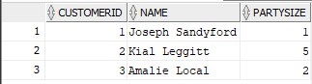

With each a transaction and a receipt:

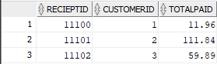

We can refer to Reciept_List table for what each customer ordered:

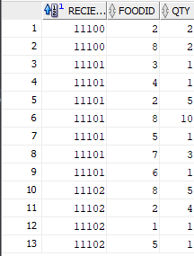

I came up with some realistic hypothetical customers that could be in my store and what they might order. The relational tables seem to be doing a pretty good job in storing and conveying the information in a readable format. I am able to tell who the customers are, how much they paid, what their receipt number is, and even which food items they ordered and how much of each. This information alone is enough to generate a analysis that is extremely useful and full of information.

**The Business Analysis**

I randomly generated 50 customers, a average number for my store, with several different party sizes and orders. I used Mockaroo as a resource to generate some of the data especially with customer orders. I left it up to RNG to generate realistic order sizes and party sizes as well as names since I am not the most creative person.

To find out what the number 1 most popular food item was, I had to filter my query to take the sum of the quantity of each food item and order them by ascending order. This allows me to pick the first row which holds the food that was ordered the most:

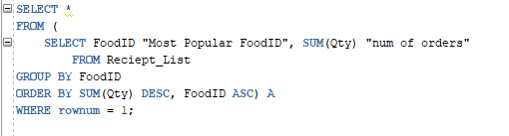

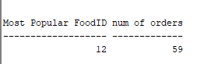

Next, I was curious to see who my employees were and how be able to compare how much each

was getting paid:

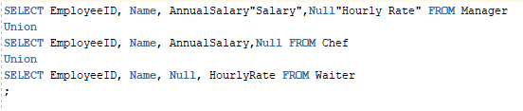

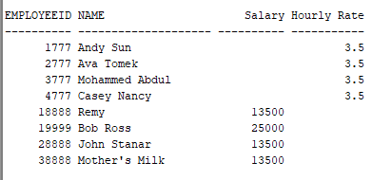

The final report I was able to generate was the monthly revenue. Using the sum of the total amount paid between all customers, I derived the monthly revenue. This was quite simple to achieve thanks to the structure of my database.



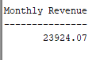

**Recommendations and Closing Thoughts**

Overall, this project has been the perfect combination of educational, fun, and challenging. I have learned a lot throughout creating this, albeit hypothetical, very realistic business that I am proud of. This has been helpful in connecting some of the learning material with real world examples and helped to answer a lot of the “why are we learning this?” questions that I usually have. If I were to redo this project, I would have to better manage my time and plan out the step a little more carefully. My lack of attention in the ERD stage has hindered my process to move further and I was forced to go back and fix my mistakes. I have learned that it is important to follow and trust the process. It works. At the beginning of this semester, had you asked me to create a database for a hot dog stand I wouldn’t know where to start. And now I am confident in my ability to create a database for any company and any purpose. I also now have the pleasure of including this course as well as this project on my resume.